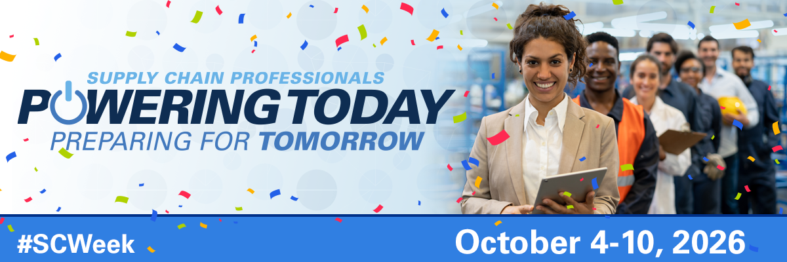
Celebrate National Health Care Supply Chain Week
October 4-10, 2026
National Health Care Supply Chain Week (SC Week), October 4-10, 2026, is an opportunity to recognize the importance of the healthcare supply chain professionals and honor them for their exceptional contributions to patient care and the innovative ways in which they support their healthcare organizations and communities.
The theme this year, “Powering Today, Preparing for Tomorrow”, celebrates the dedication of healthcare supply chain professionals who ensure quality, safety, and value at every turn, making informed choices, strengthening patient outcomes, and advancing the mission of care – the true embodiment of advancing healthcare through supply chain excellence. Below are a few key messages that you can share:
- Supply Chain Week recognizes the impact of healthcare supply chain professionals and their role in patient care and organizational excellence.

- As healthcare supply chain professionals, we play a critical role in our organizations’ efforts to deliver high-quality care at an affordable cost to patients.

- Supply Chain Week honors supply chain professionals who ensure that clinicians have access to essential medical products so they can deliver life-saving care to patients.

- Supply chain professionals ensure operational performance by collaborating and innovating with other professionals in the areas of finance, operations, patient safety, resiliency, data standards, and environmental sustainability.

