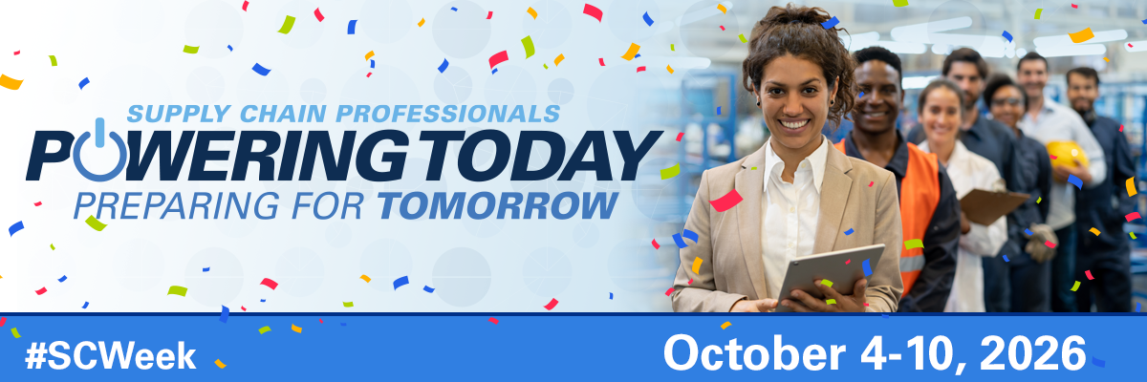
Celebrate National Health Care Supply Chain Week
October 4-10, 2026
National Health Care Supply Chain Week (SC Week) is an opportunity to recognize the importance of the health care supply chain professionals and honor them for their exceptional contributions to patient care and the innovative ways in which they respond to ongoing supply chain disruptions.
The theme this year, “Powering Today, Preparing for Tomorrow”, celebrates the dedication of healthcare supply chain professionals who ensure quality, safety, and value at every turn, making informed choices, strengthening patient outcomes, and advancing the mission of care – the true embodiment of advancing healthcare through supply chain excellence.
In recognition of the hard work and dedication of supply chain professionals who support every area of their healthcare organization, the Association for Health Care Resource & Materials Management (AHRMM) of the American Hospital Association celebrates SC Week. “We are extremely proud of the supply chain professionals who ensure that clinicians have access to essential medical products so they can deliver life-saving care to our patients,” says [Insert name, title, name of organization].
“We recognize the vital role each employee plays in building operational efficiency and resilience so we can continue to serve our communities. As we celebrate this special week, we applaud everyone’s efforts. Thank you!”
[Insert organization/department name] is celebrating SC Week with these events: [insert events titles and dates].
AHRMM invites you to commemorate SC Week with a new merchandise collection featuring the official 2026 logo and theme. You can order well-deserved gifts for your staff, colleagues and friends at jimcolemanstore.com/scweek. Share your celebration photos on all socials by using #SCWeek during National Health Care Supply Chain Week.

